**ASSIGNMENT-4**

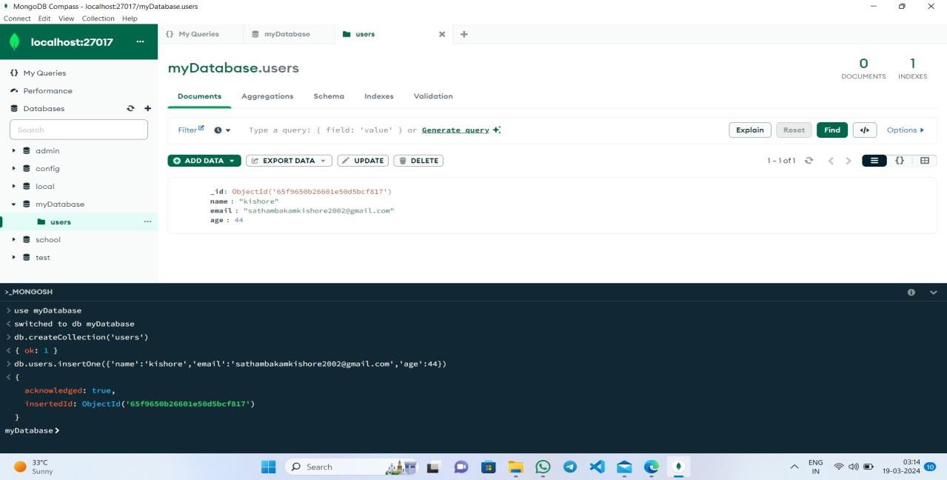

Name:M.Jaisai

Hallticket:209F1A0525

Gmail:jsai5442@gmail.com

Course:FullStackDevelopment(MERNSTACK)College:SriVenkateswaraInstituteofTechnology

**Creating a Database Using MongoDB and**

**Mongosh**

Database Setup and Collection Creation

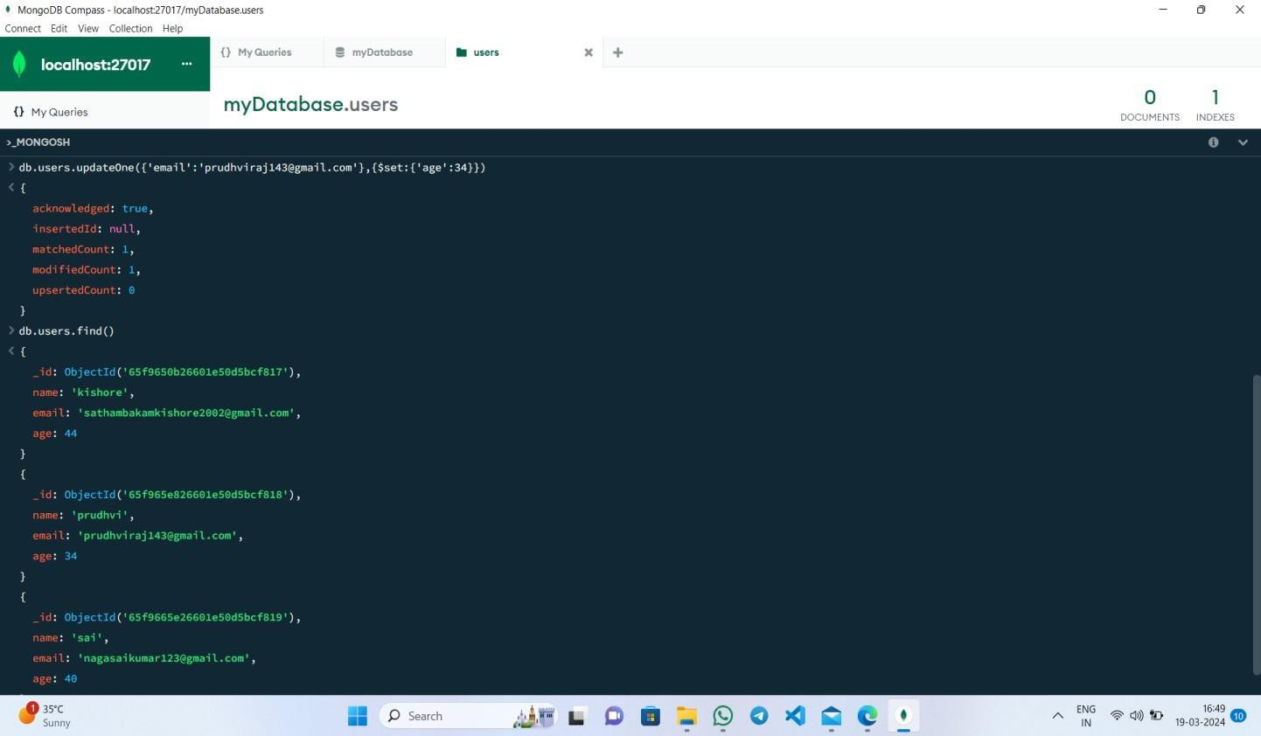

**Document Insertion**

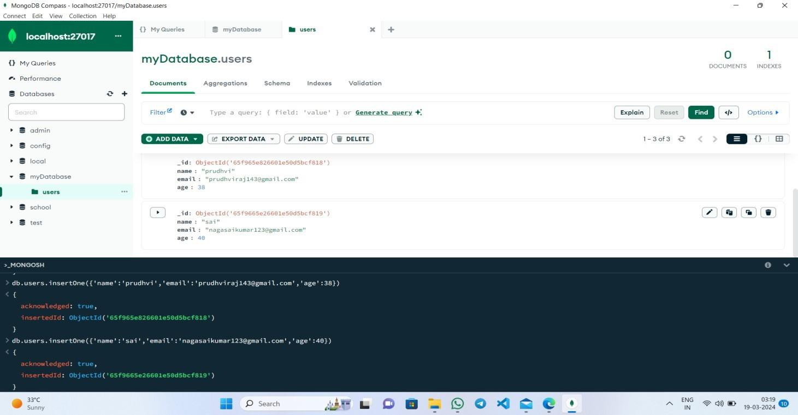

**Update Operation**

**Deletion Operation**

